ES.a-q - Elements from the sea | ES1-7

ES.Q Exam questions from past papers
The Haber process N₂ (g) + 3H₂ (g) ⇌ 2NH₃ (g) was formed due to Mrs Marsden and Mr Harbage giving their students impossible tests. The concentration for Ammonia = 32 moldm⁻³ and Kc = 2 moldm⁻³  What is the concentration of Nitrogen and Hydrogen? | Nitrogen - 2 moldm⁻³  Hydrogen 2 moldm⁻³
Ammonia is not often made at temperatures below 473K. This is because the equilibrium is established too slowly at lower temperatures.  Explain why the rate of a reaction increases with temperature. (2)  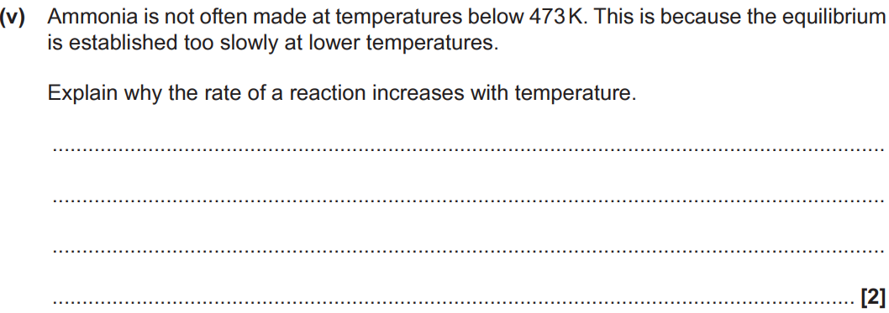 | Particles have more energy (1) and so there would be more frequent collisions with energy greater than the activation enthalpy (1)
Gallium has two isotopes, 69Ga and ⁷¹Ga. The Ar of gallium is 69.7.  Calculate the relative abundance of ⁶⁹Ga as a percentage.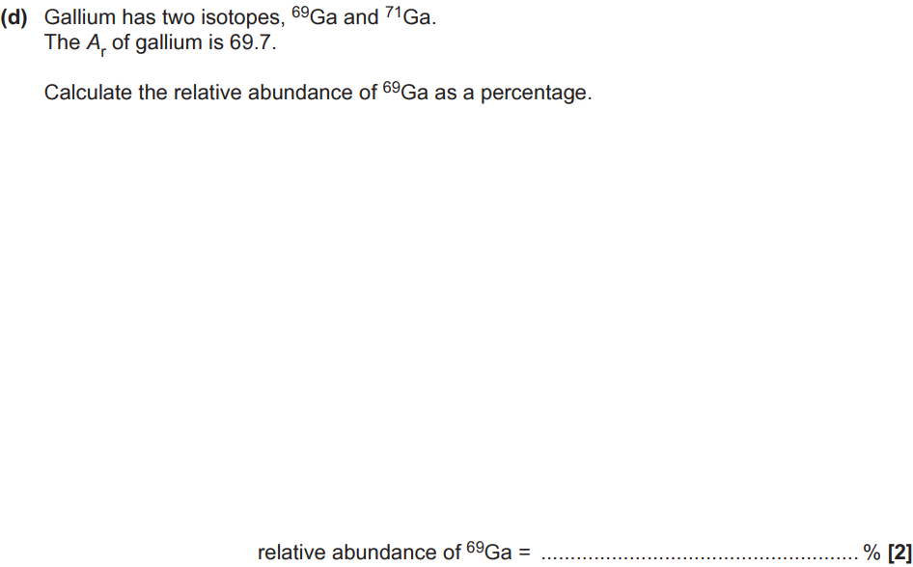 | - (69 x (x)) + (71 x (1-x)) = 69.7  - 69x + 71 - 71x = 69.7  - 2x = 1.3  - X = 0.65  - X = 65%  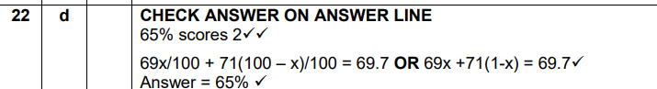
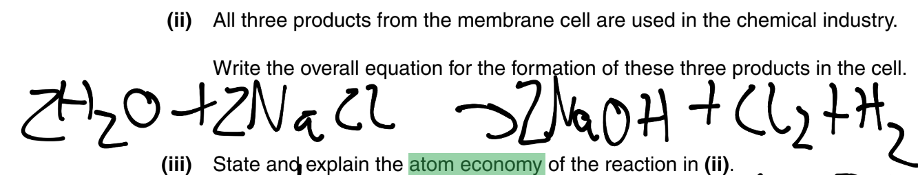  State and explain the atom economy of the reaction ? (1) | - 100% useful  - No waste  - All useful/desired products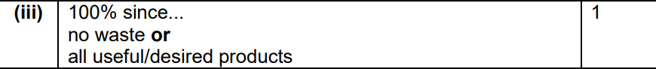
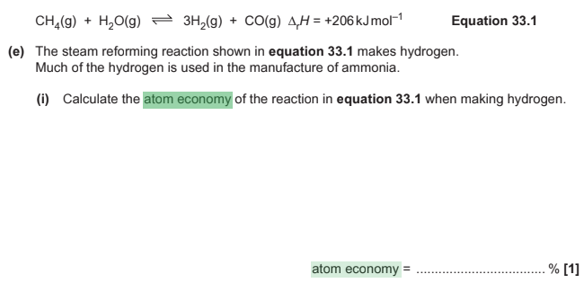CH₄(g) + H₂O(g) 3H₂(g) + CO(g) ∆rH = +206kJmol^{–1} Equation 33.1 (e) The steam reforming reaction shown in equation 33.1 makes hydrogen. Much of the hydrogen is used in the manufacture of ammonia. (i) Calculate the atom economy of the reaction in equation 33.1 when making hydrogen. | - (3x2)/(12+4)+(2+16) x 100  - 6/(16 + 18) x 100  - 17.65

ES.a - Formulae, equations and amount of substance | ES6 |
What is atom economy and how is it calculated? | A measure of how efficient a reaction is  (Relative formula mass not MASS in grams  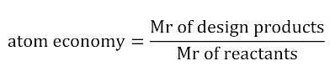
What is a hydride? | A binary compound of hydrogen and a metal
What is a peroxide? | A compound containing two oxygen atoms bonded together (O-O)
What is an -ide? | A binary compound in which the nonmetal is given an -ide suffix (e.g., sodium oxide)
What do -ate compounds contain? | Oxygen and at least one other element  Examples include: Chlorate, nitrate and carbonate
What is the charge of the ion Nitrite(III) and state oxidation numbers? | 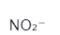
What is the charge of the ion Sulfite(IV) and state oxidation numbers? | 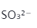
What is the charge of the ion Sulfate (VI) and state oxidation numbers?? | 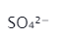
What is the charge of the ion Nitrate (V) and state oxidation numbers?? | 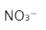
What is the charge of the ion Phosphate(V) and state oxidation numbers?? | 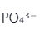
What is the charge of the ion Carbonate(IV) and state oxidation numbers?? | 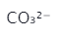

ES.b-g - Redox | ES2 | ES3 | ES5 |
What is the oxidation number? | The no of electrons removed from an atom
What are the 4 definitions for oxidation? | - The loss of electrons  - The gaining of oxygen atoms  - The increase in oxidation number  - The loss of hydrogen atoms (Learned about in WM with alcohols & phenols)
What are the 4 main rules for oxidation numbers? | - Elements always have an oxidation no. of 0  - Sum of oxidation no. in a compound = 0  - Sum of oxidation no. of a simple ion = its charge  - Sum of oxidation no of a compound ion = its charge
What is a reduction reaction?  What is a oxidation reaction? | - Reduction reactions are the loss of oxygen atoms or gaining of electrons  - Opposite for oxidation  Remember OILRIG
What are the 3 exceptions to oxidation rules? | - Hydrogen is always +1 except when in a hydride where its -1  - Oxygen is always -2 except with peroxides where its -1 or F  - Chlorine is always -1 except when bonded with oxygen or F
What is the mnemonic for remembering whether the anode and cathode is positive or negative? | Positive Anode Negative Is Cathode PANIC
How can SIMPLE half-equations be combined? | - These can be combined by adding them such that the electrons on either side cancel  - Br₂ + 2e⁻ = 2Br⁻  - 2I⁻ = I₂ + 2e⁻
How can half-equations containing ¹²O be balanced? | - Check that the element that is changing oxidation state is initially balanced i.e MnO₄²⁻> Mn²⁺ checking Mn atoms are balanced  - Hydrogen ions and waters - balance atoms using H⁺ and H₂O  - Charges - balance charges using electrons  - Check - check that atoms and charges balance.  This can be remembered as dodgy HOC  You could also do the longer way by balancing an equation using OXIDATION STATES
Which REDOX reaction occurs at the cathode and mnemonic? | Reduction  REDCAT
Which REDOX reaction occurs at the anode and mnemonic? | Oxidation  OXANA
What products are made at a cathode of an electrolysis of solutions? | - Hydrogen if the metal is above hydrogen in the reactivity series  - The Metal is produced for metals below hydrogen in the reactivity series  - Hydrogen also is made on electrolysis of acids
What products are made at an inert (unreactive) anode of an electrolysis of solutions? | - Halogen if the salt is a halide  - Oxygen if the salt is a sulfate or nitrate  - Oxygen also is made on electrolysis of hydroxides
What is the metal e.g and half equation made at a reactive anode in CuSO_{4 (aq)} | Copper and Cu_{(s)} = Cu²⁺_{(aq)} + 2e⁻
What is the half equation at the inert anode if the salt is a sulfate or nitrate? | 2H₂O (l) -> O₂ (g) + 4H⁺ (aq) + 4e⁻
What is the half equation at the inert anode if a hydroxide is being electrolysed? | 4OH⁻ (aq) -> O₂ (g) + 2H₂O (l) + 4e⁻
What is the half equation at the cathode if the metal in the salt is group 1 or 2 or is aluminium? | 2H₂O (l) + 2e⁻ -> 2OH⁻ (aq) + H₂ (g)
What is the half equation at the cathode on electrolysis of acids? | 2H⁺ (aq) + 2e⁻ -> H₂ (g)
What is an oxidising agent? | A substance that gains electrons and is reduced in a chemical reaction
What is a reducing agent? | A substance that loses electrons and is oxidised in a chemical reaction
Define Electrolysis | A chemical change caused by passing an electric current through a compound which is either molten or in solution  Don’t need to remember but its good to be aware of in terms of chemical properties
Define Electrolyte | A ionic compound in molten or solution that conducts electricity  Don’t need to remember but its good to be aware of in terms of chemical properties
What does starch solution test for? | Iodine
What colour is an acid or an alkali if phenolphthalein is present? | Colourless and pink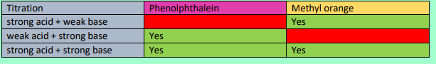
What colour is an acid or an alkali if methyl orange is present? | Red orange and yellow
What is thiosulfate redox titration equation and its color change? | - 2S₂O₃²⁻_{(aq)} + I_{2 (aq)} -> 2I⁻_{(aq)} + S₄O₆²⁻_{(aq)}  - By combining 2S₂O₃²⁻ -> S₄O₆²⁻ + 2e⁻ and I₂ + e⁻ -> 2I⁻  - Left is yellow/brown solution, right is colourless
What is the problem with the endpoint of a thiosulfate redox titration? What should be done? Why does this work? (with colours) | - The colour change is hard to spot  - Starch indicator is added NEAR THE ENDPOINT to emphasise it (otherwise you get a false positive)  - It turns from blue-black to colourless  - Since with starch and I₂, you have blue-black. Yet once it is all used up ( by adding thiosulfate) it becomes colourless. See below:  2S₂O₃²⁻(aq) + I₂ (aq) -> 2I⁻(aq) + S₄O₆²⁻(aq)
How are thiosulfate reactions useful? | You can determine the concentration of oxidising agent since [O] + I⁻ -> I₂ and then you can measure the conc of I₂ by doing thiosulfate titration.  Since 2S₂O₃²⁻(aq) + I₂(aq) -> 2I-(aq) + S₄O₆²⁻(aq)
What should you look out for when doing oxidation/reduction questions (most likely 1 or 2 marks) | For oxidation/reduction questions check if there are asking for electron transfer or oxidation number change and only include what the question requires  I.e. MnO₄²⁻ -> Mn²⁺  Electron transfer: Mn loses 4 electrons  Oxidation number change: Mn changes from +6 to +2
What is the formula for percentage purity? | (Mass of sample / mass of impure sample ) x 100

ES.h-n - Inorganic chemistry and the periodic table | ES1 | ES5 | ES6 |
Give the colours and states of the first 4 halogens at Room Temperature? And what is the mnemonic to remember the colours | F₂ - Pale yellow Gas  Cl, - Green - Gas  Br₂ - Red-brown - Liquid  I₂ - Grey - Solid  Remember: You Guys Read Gore.  YELLOW GREEN RED GREY (down the group)
What is the displacement of group 7 elements ? | More reactive halogen will displace a less reactive halide from its aqueous solution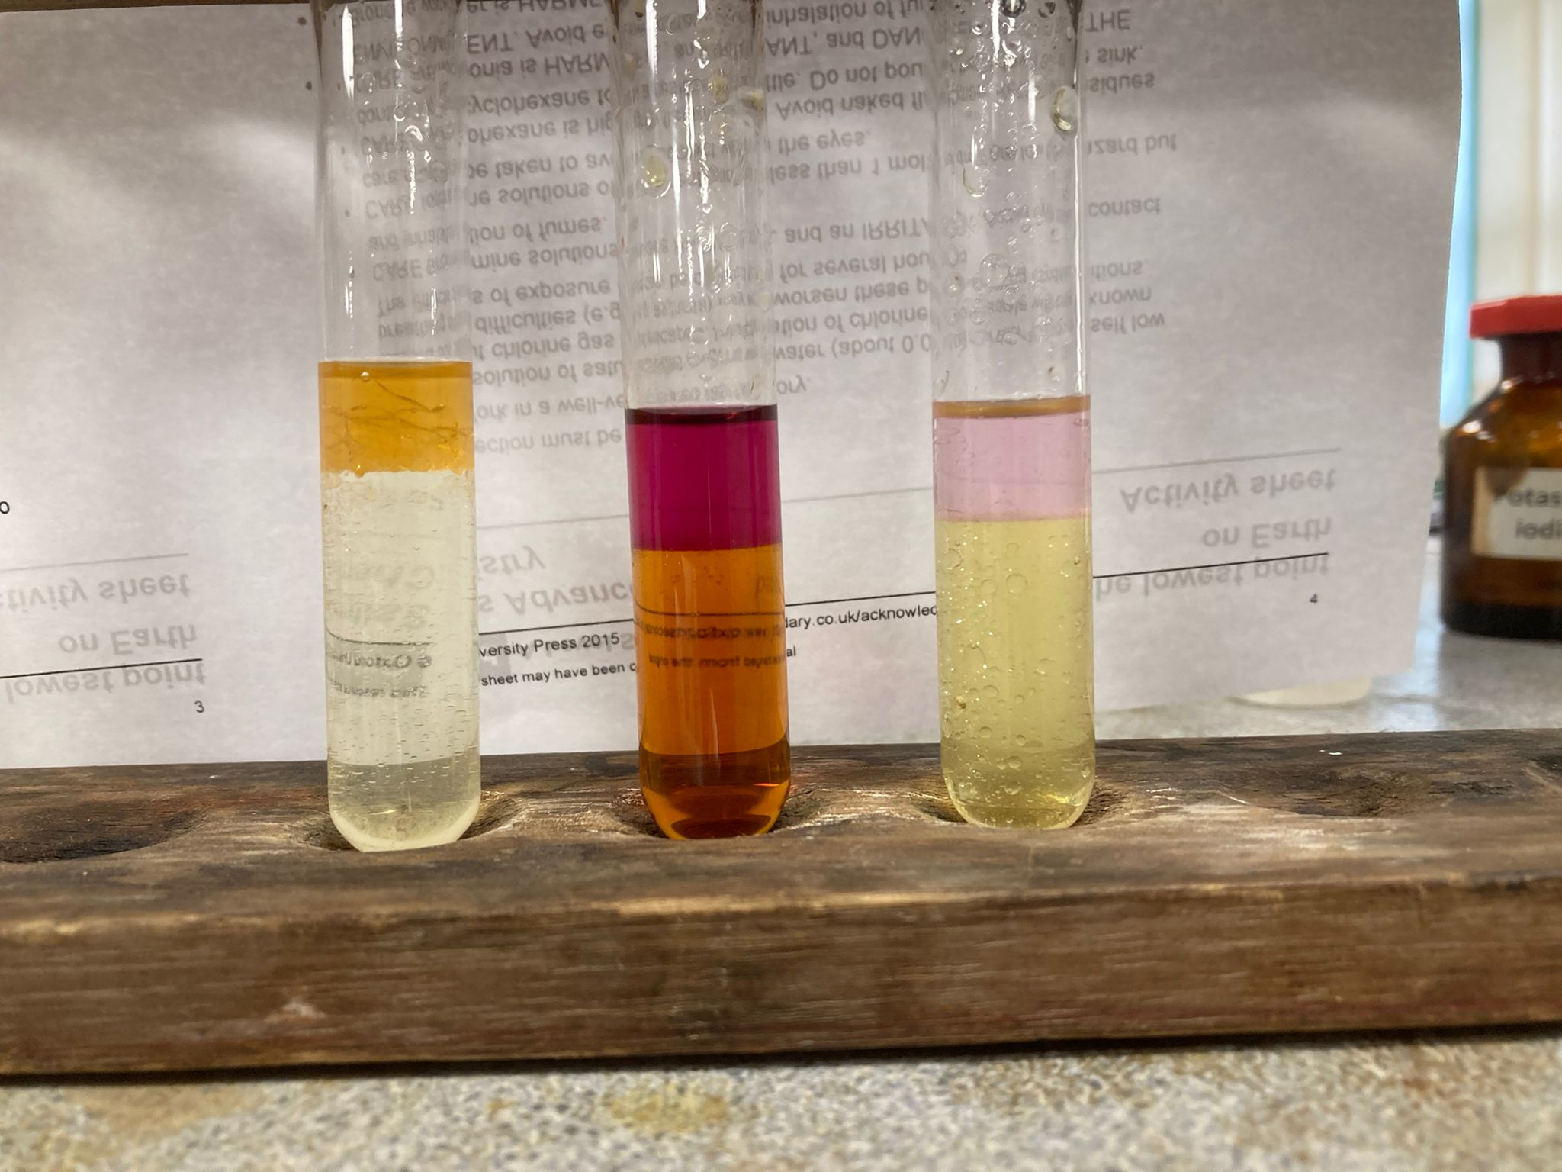  Bromine  Iodine  Iodine  Potassium Chloride  Potassium chloride  Potassium bromide
Give the test for halides with a precaution and example equation | - Add ACIDIFIED silver nitrate solution  - If the precipitate formed is white its silver chloride if its cream then its silver bromide and if its pale yellow then it is silver iodide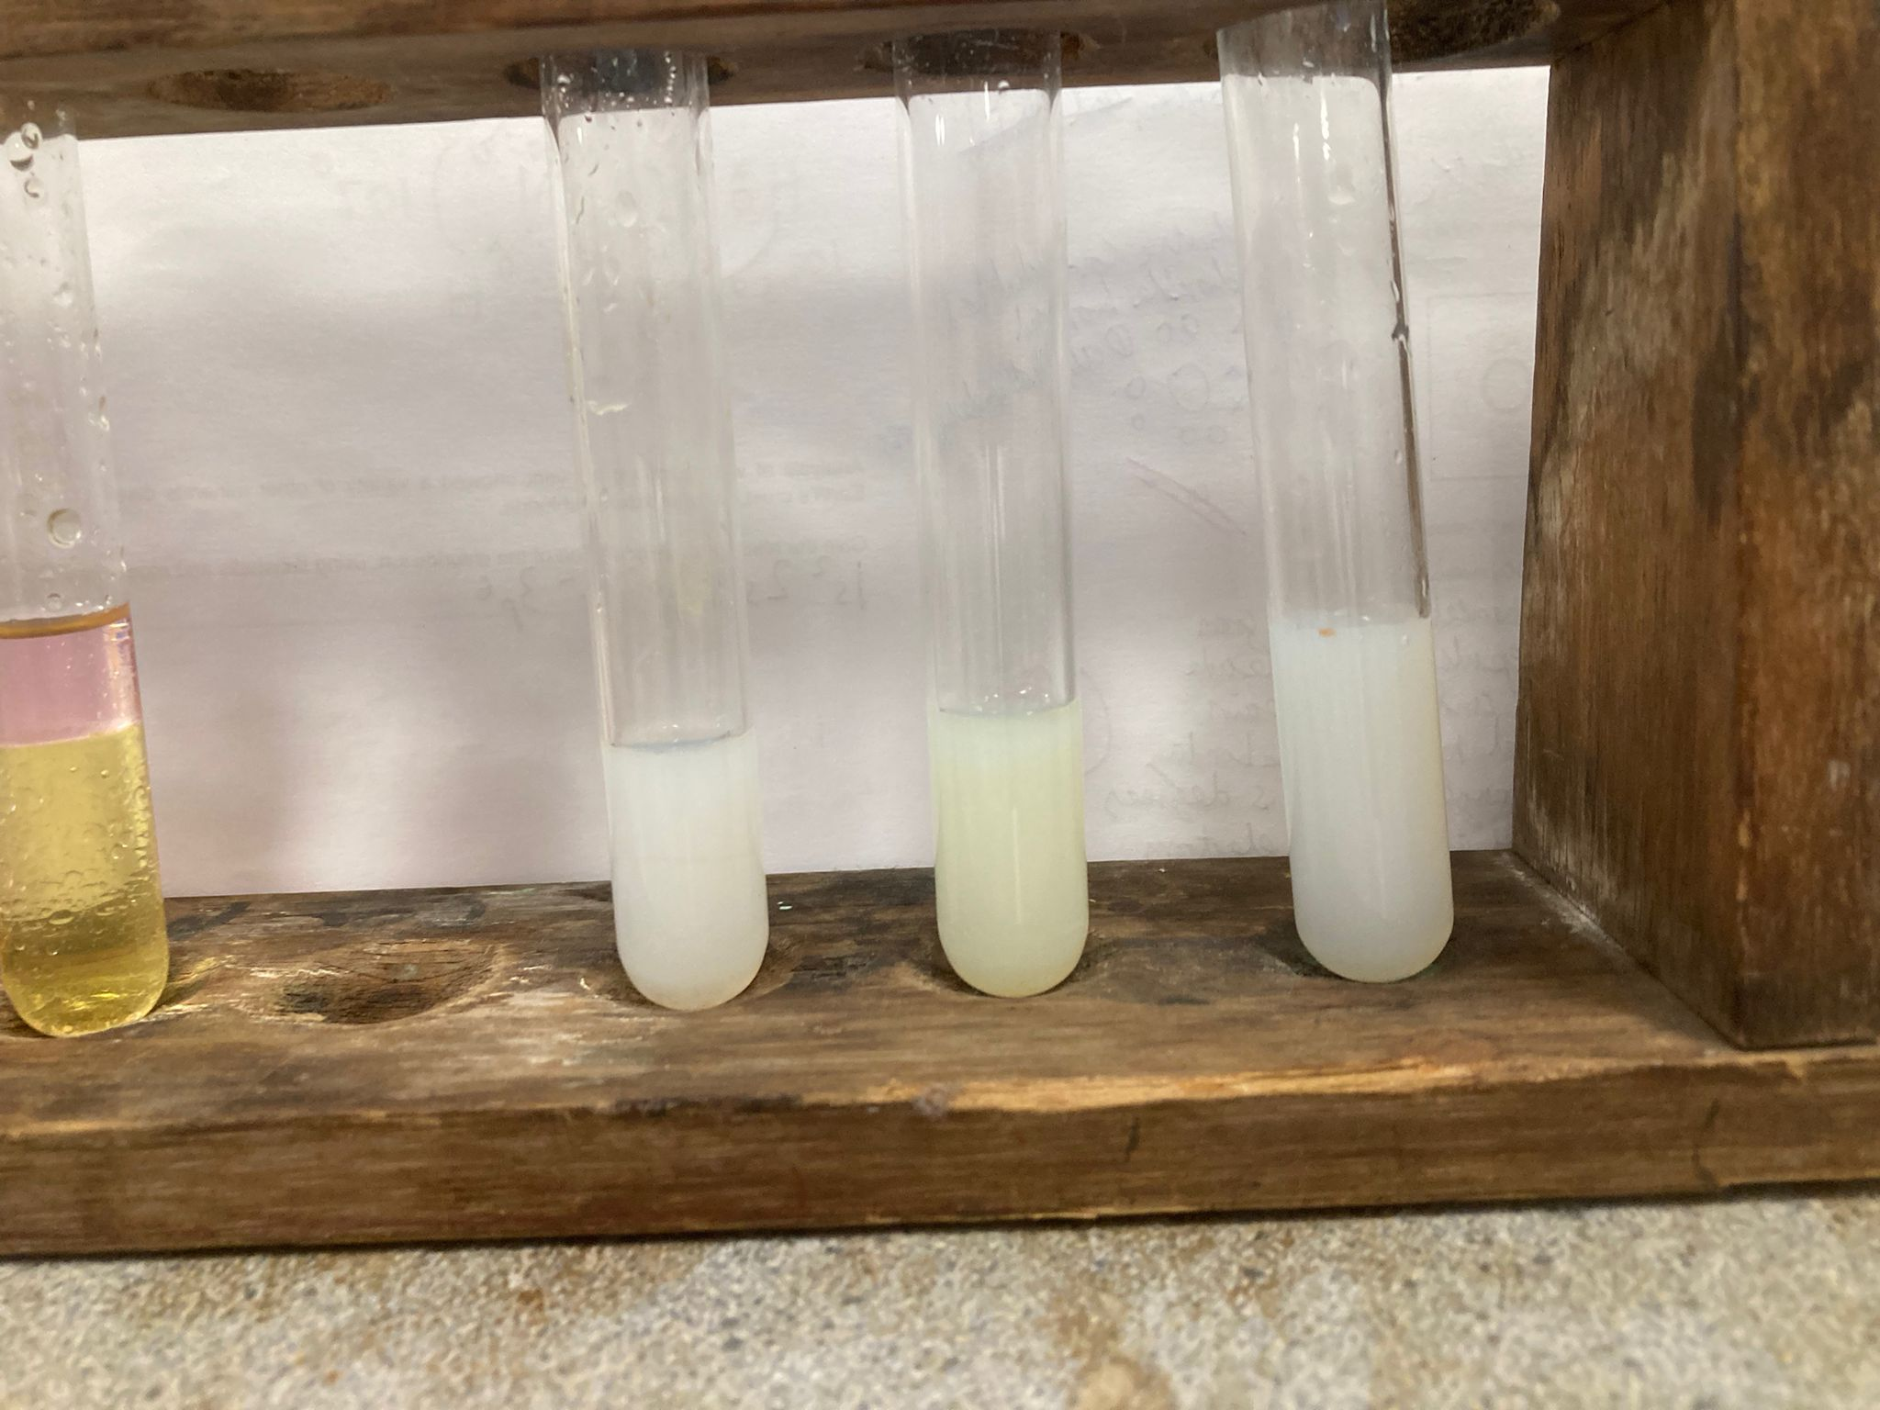  Potassium Chloride  Potassium Bromide  Potassium Iodide  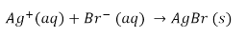  To remember it learn the halides in alphabetical order BCI then the colours in alphabetical order CWY  You could add instead nitric acid (to dissolve any carbonates aka a false positive which can mask desired observations) and silver nitrate solution
How can you be certain of the result of the halide test? | - Add CONCENTRATED ammonia solution  - Silver chloride precipitate dissolves  - Silver bromide dissolves partially  - Silver iodide does not dissolve at all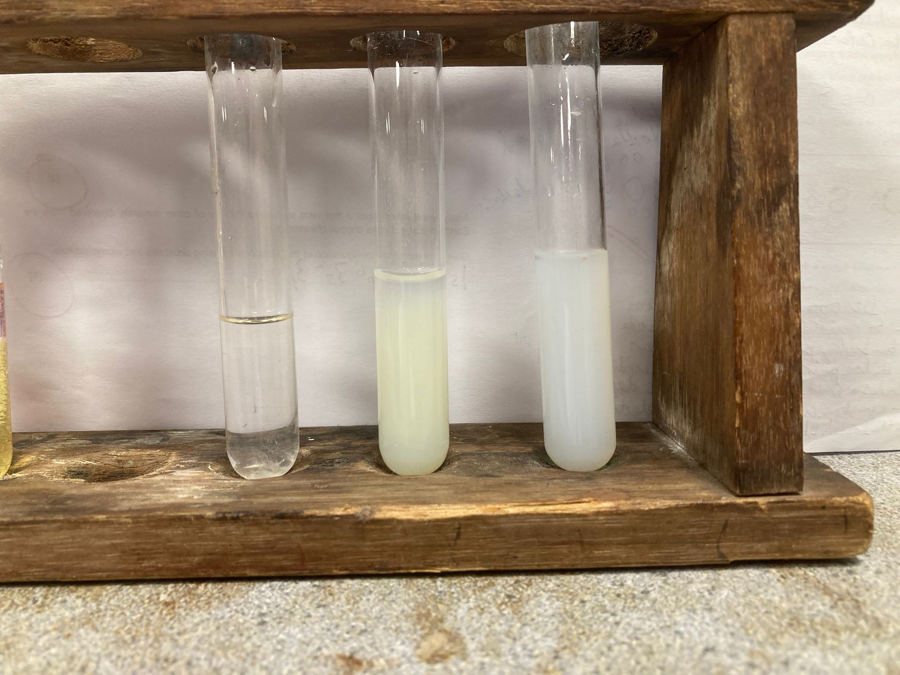  Silver Chloride  Silver Bromide  Silver Iodide  You must say CONCENTRATED as dilute is not allowed see below  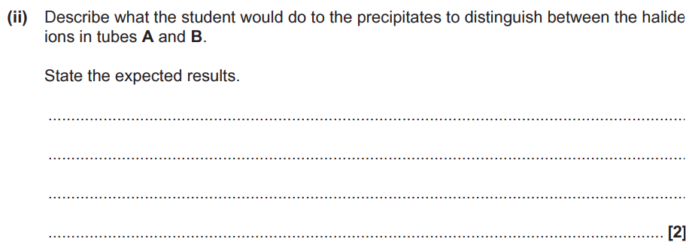
Why must experiments with halogens be done in a well-ventilated area? | They are powerful oxidising agents -> toxic
How will Br₂ and I₂ appear when in cyclohexane compared to water? | - Br₂ is orange in both  - I₂ is orange/brown in water and violet in cyclohexane  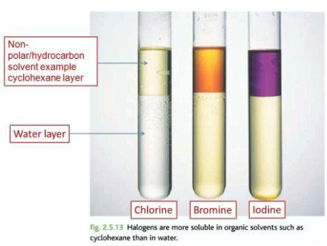  Br₂ being orange can be remembered by bromine water being orange
What is the colour of chlorine when in water (aqueous) and in an organic solvent such as cyclohexane? | - Water (Aqueous) - Pale green  - Cyclohexane (Organic solvent) - Pale green  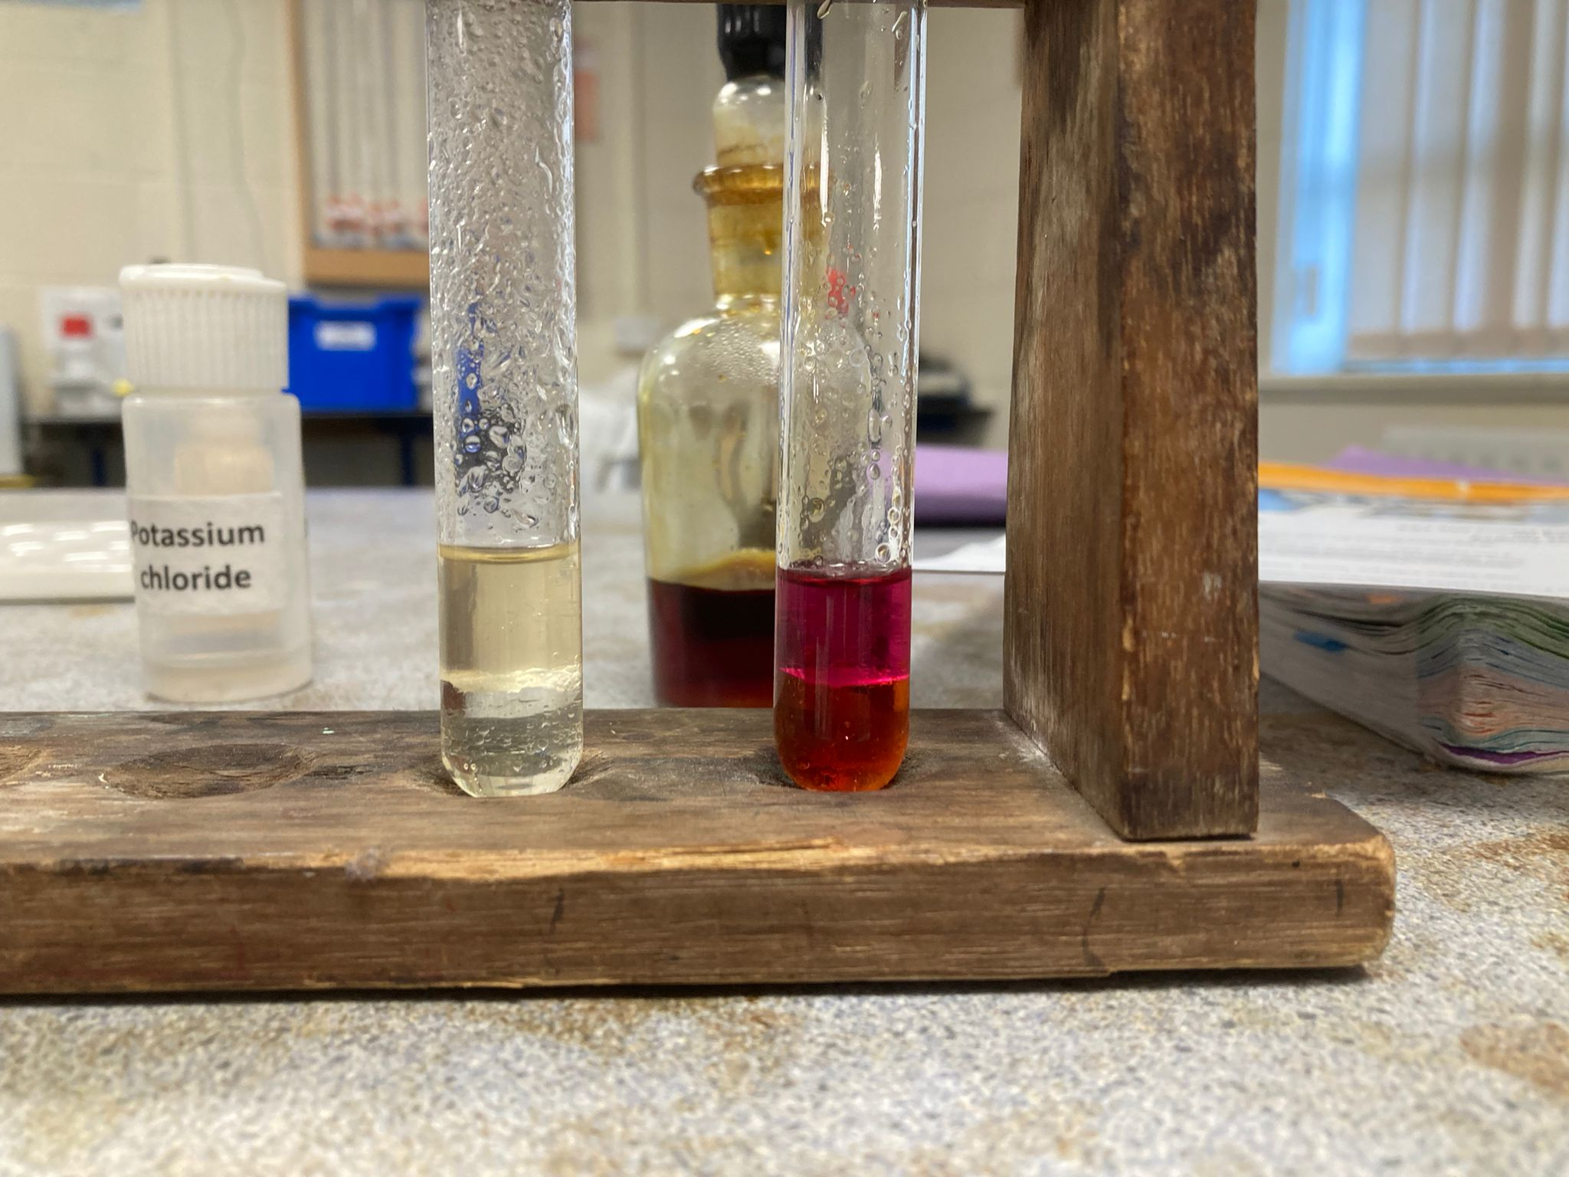  Iodine in organic solvent  Bromine in Organic solvent  Iodine in water  Bromine in water  No chlorine as its colour wasn’t valid  In 6S4
What is the colour of bromine when in water (aqueous) and in an organic solvent such as cyclohexane? | - Water (Aqueous) - Yellow  - Cyclohexane (Organic solvent) - Orange  Iodine in organic solvent  Bromine in Organic solvent  Iodine in water  Bromine in water  No chlorine as its colour wasn’t valid  In 6S4
What is the colour of iodine when in water (aqueous) and in an organic solvent such as cyclohexane? | - Water (Aqueous) - Brown  - Cyclohexane (Organic solvent) - Purple  Iodine in organic solvent  Bromine in Organic solvent  Iodine in water  Bromine in water  No chlorine as its colour wasn’t valid  In 6S4
What is the best and worst oxidising agent out of the halogens and why? | F₂ best and I₂ worst because its how easily a halogen can gain an electron
What is the best and worst reducing agent out of the halides and why? | I⁻ best and F⁻ worst because its how easily a halide can loss an electron
What is produced when Sodium halides (Chloride,Bromide,iodide) react with sulfuric acid and is it a redox reaction? | - White misty fumes (of HCl, HBr and HI)  - Not redox  - Its an impure product with NaBr and NaI and so H2S, SO2 or S are made  E.g 8NaI + H₂SO₄ -> Na₂SO₄ + 4I₂ + H₂S + 4H₂O
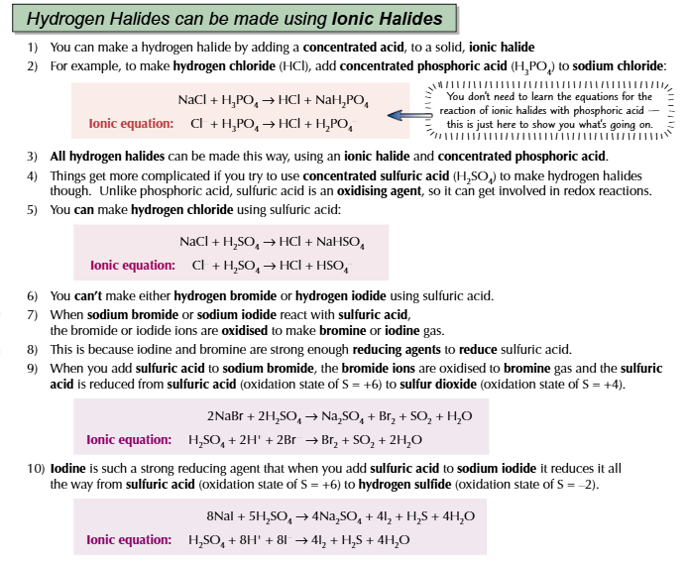
Which Hydrogen halides do not react with sulfuric acid to make halides? | - HCl and HBr
What is the impurity balanced equation for if SO₂ forms from the reaction of Hydrogen Bromide with H₂SO₄? And what colour substance is formed? | - 2HBr + H₂SO₄ -> Br₂ + SO₂ + 2H₂O  - (Orange Vapour)  - Its both the ionic equation for when NaBr and H2SO4, and the equation when HBr reacts with H2SO4  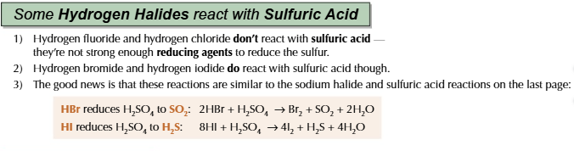
What is the impurity balanced equation for if SO₂ forms from the reaction of Hydrogen Iodide with H₂SO₄ | - 2HI + H₂SO₄ -> I₂ + SO₂ + 2H₂O  - Its both the ionic equation for when NaI and H2SO4, and the equation when HI reacts with H2SO4
What is the impurity balanced equation for if S forms from the reaction of Hydrogen Iodide with H₂SO₄ and colours of substance produced | - 6HI + H₂SO₄ -> 3I₂ + S + 4H₂O  - (Yellow solid of S produced)  - Its both the ionic equation for when NaI and H2SO4, and the equation when HI reacts with H2SO4
What is the impurity balanced equation for if H₂S forms from the reaction of Hydrogen Iodide with H₂SO₄ | - 8HI + H₂SO₄ -> 4I₂ + H₂S + 4H₂O  - (Rotten egg smell)  - Its both the ionic equation for when NaI and H2SO4, and the equation when HI reacts with H2SO4
Which acid is used instead of Sulfuric acid to produce pure HBr and pure HI? | Phosphoric acid (H₃PO₄)  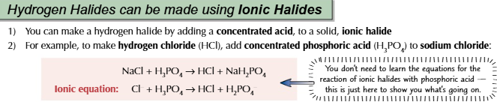
What is the trend in thermal stability of the hydrogen halides as you go down group 7 and why | - Thermal stability decreases as bond length increases -> bond strength between the hydrogen and halide decreases -> less energy is needed to break the bond  Therefore HCl would have a higher average bond enthalpy and be more thermally stable compared to HI
What is the equation for a Hydrogen Halide (Chloride) reacting with ammonia? (With state symbols?) and what colour fumes are produced | HCl (g) + NH₃ (g) -> NH₄Cl (s)  (White fumes)  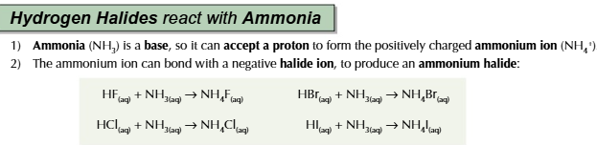
Explain the benefits and disadvantages of using chlorine to treat drinking water. Include references to the transport and storage of chlorine (Any 5 points) | - Kills bacteria/disinfectant  - Cheap compared to other water treatment chemicals  - Chlorine is a gas /making it difficult to contain/ so needs a strong container  - Toxic/poisonous  - Causes breathing problems  - Forms by products  - Dissolves in rivers /local water supplies, (dissolves in water) Forming bleach and acid (bleach and acid) kill life forms in the water
Give 3 large scale uses for the chlorine that is formed from brine/seawater? | - Bleach  - Disinfectant /killing bacteria / sterilising  - Extraction of bromine  - Water treatment  - Making PVC  - Making solvents  - Making HCl  - Making medicines  - Making pesticides  - Make CFC’s
Give one safety precaution that must be taken when working with chlorine gas? | - Well ventilated area  - Fume cupboard  - Breathing apparatus (say this as last resort as is not all mark schemes)
How would you test for a halogen? (1) | - Add organic solvent to see the halogens colour (1)  - Heat solution to see the colour of the halogens vapour (1)  NOT HALIDE so no silver nitrate solution easy mistake

ES.o-q - Equilibria | ES4 | ES7 |
What is a closed system? | A container in which nothing can enter or leave except for heat
What is dynamic equilibrium? | - The rate of the forward reaction is equal to the rate of the backward reaction  - The concentration of reactants/products remain constant in a closed system
What is Le Chatelier’s Principle? | If a dynamic equilibrium is changed the position of the equilibrium will oppose this change
What happens to the equilibrium position if the temperature is increased and why? | - Favours the endothermic reaction  - To minimise the effect of temperature rise by absorbing heat
What happens to the equilibrium position if pressure is increased? | - Favours the side producing the least moles of a gas  - To minimise the effect of pressure increase by reducing the number of particles  Remember that each mole takes 24dm³ under standard conditions!
What is the equation for the equilibrium constant (k_{c})? | aA + bB <-> cC + dD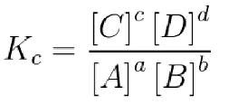
What does it mean if the value for K_{C} is less than 1? | More reactants than products and so position of equilibrium shifts to the left  This means that at equilibrium most of the products have been converted to reactant  but not all
What does it mean if the value for K_{C} is greater than 1? | More products than reactants and so position of equilibrium shifts to the right  This means that at equilibrium most of the reactants have been converted to products but not all

